Open Source Impedance Fitter

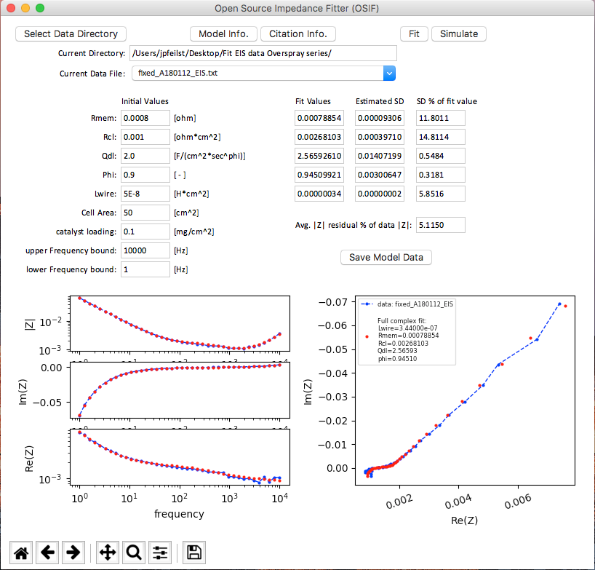

Jason Pfeilsticker

To use OSIF:

* If you have python already installed on a Windows computer, go ahead and move the python.exe file from the C:\python## directory to the C:\Users\YOURUSERNAME directory or which every directory your command prompt defaults to opening. This will save you work down the line.
* If you already have python 3.x or 2.x installed, make sure you have the scipy, numpy, xlrd, and matplotlib modules installed. If these are not installed, do so using your package manager (pip, port, conda…) or follow step 2 and on.
* If you have the modules installed, then follow step 3 and on.
* If you have multiple version of python installed (Macs come with python 2 pre-installed by apple) you might have to replace ‘python’ with ‘python3’and ‘pip’ with ‘pip3’ in some commands for them to work.
* If you don’t know what any of the above means, start at step 1.
* If you have questions or find issues email [jason.pfeilsticker@nrel.gov](mailto:jason.pfeilsticker@nrel.gov)
* GitHub repository of code and pertinent information: <https://github.com/NREL/OSIF>

**Contents**

1. Python instillation
2. Ensuring needed modules are installed
3. How to run the OSIF program
4. How to use the OSIF program
5. Important things to know **(MUST READ THIS)**
6. Known issues
7. make sure you have python 2 or 3 installed; Macs come with python 2 installed already (skip to step 2 unless you want python 3).
   1. If on Mac:
      1. open a terminal and type ‘python ‘--version’ without quotes and hit enter.
      2. You should see something like ‘Python 3.#.#’or ‘Python 2.#.#’pop up.
      3. If you do not, then install python.
   2. If on windows, perform a windows search for ‘python’. If ‘python.exe’ shows up in the search, you have python installed. Right click the python.exe and click ‘open file location’.
      1. It is highly suggested that you move this python.exe file (CUT and paste) to whatever the default directory is when you open up command prompt. This is normally C:\users\YOURUSERNAME
      2. Moving the python.exe to this location will allow you to run python files (like OSIF) very quickly from the command prompt.
   3. If you don’t not have python installed, you will need to install it:
      1. To install on windows, click on ‘download’ either 2.x or 3.x at: <https://www.python.org/downloads/> and follow the default instructions. Make sure to select the “Add to PATH” option during the installation!
         1. Once you are done with the installation, find the python.exe file by performing a windows search for ‘python’ and cut (not copy) and paste it to the C:\users\YOURUSERNAME file or what ever the default command promt directory is. This will make opening and running commands from console much easier later.
      2. To install python 3 on Mac if you want it, go: <https://www.macports.org/install.php> This is a bit more involved and complicated, maybe ask IT to help install python with a framework using Xcode. Installing it as given on the python website will result in the program not working because it needs the framework to communicate with MacOS.
8. Make sure you have the xlrd, scipy, numpy, and matplotlib modules installed
   1. Open a console (terminal on a Mac or command prompt in windows) then open a python shell in that console.
      1. type in python and hit enter, wait till you see ‘>>>’ indicating you are in a python shell.
      2. Enter ‘import ModuleName’ without quotes and replacing ModuleName with the module you want to check.
      3. if you see an error like ‘ModuleNotFoundError: No module named ModuleName’ you need to install that module. Do this for the above-mentioned modules.
      4. once you know what modules you are missing enter ‘exit()’ without quotes to exit the python shell and get back to the normal console.
   2. To install a module on a mac:
      1. In a terminal window type ‘sudo pip install ModuleName’ replacing ModuleName with the module you need.
      2. it will ask for a password, this is your normal login password, it will now show anything while typing.
      3. Check to see if it was installed correctly by performing 2.a again. If not, then try replacing ‘pip’ with ‘pip3’ or with whatever package manager you are using (port, conda, etc…)
   3. To install a module in windows:
      1. Open a command prompt
      2. enter ‘python -m pip install ModuleName’ replacing ModuleName with the module you need.
      3. Check to see if it was installed correctly by performing 2.a again.
9. Running OSIF:
   1. Open the OSIF.py file in a text editor (notepad in windows, textedit on a Mac) by right clicking on it and selecting ‘open with’.
      1. If you are using python 2.x put three apostrophes above and below the python 3 tkinter import section at the top of the file.
      2. If you are using python 3.x put three apostrophes above and below the python 2 tkinter import section at the top of the file.
      3. Save the file with the same name and extension (.py)
   2. To run without using a console:
      1. Right click on the OSIF.py file and select ‘open with’
      2. On mac, select ‘python launcher 3.x’ or ‘python launcher 2.x’ depending on your installed python version and the edits made in 3.a.
      3. For windows select ‘python’
   3. To run using a console:
      1. Open terminal (mac) or command prompt (windows)
      2. Type in ‘python FilePath.py’ without quotes and replacing file path with the location and name of the OSIF.py file.
      3. FilePath might looks like: C:\Users\JSmith\Desktop\OSIFv1.0.py for windows or /Users/JSmith/Desktop/OSIFv1.0.py on a Mac. This will change depending on where you saved the OSIF.py file.
10. To use OSIF:
    1. Quick start:
       1. Click ‘Select Data Directory’ and choose the directory with your data in it.
       2. From the ‘Current Data File’ drop down, select a file you want to model.
       3. Select the initial values for the fitting algorithm (default values might work fine)
       4. Click ‘fit’
    2. If the model doesn’t fit well
       1. Adjust the parameter ‘initial values’ and hit ‘simulate’. This will plot the model using the initial values as the parameters without doing any fitting.
       2. Iterate through changing the initial values and simulating until you get the model close to the data.
          1. In general, Rmem acts as a horizontal shift, Qld lengthens the Nyquist plot in the negative Z’’ direction, Lwire does the same but positive, Rmem widens the 45° step region, and Phi changes the angle of the asymptote in the negative Z’’ direction.
    3. To save the model data:
       1. Click the ‘Save Model Data’ button. This creates a ‘YourSample’sFileName_fit.txt’ file in the same directory as your input data file which contains the model’s values at the input data’s frequencies along with the fitted parameters and estimated standard deviations and goodness of fit metrics (see section 5.b)
11. **Important things to note:**
    1. Data file formatting
       1. The program can accept the raw .txt, .xls, and xlsx files from the spectrometer’s software. You do (should) not need to modify these file for them to run in OSIF.
       2. The program can automatically detect and account if your data is in the –Z’’ or Z’’ format as long as it is labeled as such in the header of the data file (it is in default output files)
       3. To load your own data file and not an output file from the spectrometer software, make a .txt file with tab delimited columns of: Frequency, Z’, Z’’, and |Z|.
       4. Make sure your data is read correctly via the console window.
       5. For example-data files check the GitHub repo at: <https://github.com/NREL/OSIF>
    2. Goodness of Fit metrics
       1. The estimated standard deviations come from taking the square root of the diagonal elements of an approximated covariance matrix of the cost function with respect to the parameters at the final fit values.
       2. The standard deviations are first order approximations. If you are going to publish these values, explicitly state this and possible how they are calculated in your supplemental information.
       3. The cost function is minimized in order to achieve the fit. it is the L2 norm of the residuals of the real and imaginary parts of the model with respect to the data:

$$Cost Function=\sqrt{\sum_{{}_{i}}{\left({\left(Z^{'}{\left({}_{i}\right)}_{model}-Z^{'}{\left({}_{i}\right)}_{data}\right)}^{2}+{\left(Z^{''}{\left({}_{i}\right)}_{model}-Z^{''}{\left({}_{i}\right)}_{data}\right)}^{2}\right)} }$$

Where $Z^{'}$ and $Z^{''}$ are the real and imaginary parts of the impedances respectively in ohms and ${}_{i}$ is the frequency in Hz for the i’th input frequency from the loaded data and selected range.

* + 1. From my experience, generally ‘SD % of fit values’ below ~15 are good and an ‘Avg. |Z| residual % of data |Z|’ values less than 10 is a pretty good fit, but let your eyes guide you, as stated, these standard deviations are approximations. That being said, most fitting programs calculate them in the same way.
    2. The ‘Avg. residual % of data |Z|’ (where |Z| is the complex modulus of the impedance, not the absolute value) metric is calculated as:
 $$Avg. \left|Z\right| residual \% of data \left|Z\right|=\frac{100}{\#dataPoints}* \sum_{{}_{i}}{\frac{\left|Z_{model}\left({}_{i}\right)\right|-\left|Z_{data}\left({}_{i}\right)\right|}{|Z_{data}({}_{i})|}}$$

 1. The model being fit to can be found by hitting the ‘Model Info.’ Button or by going to: <http://jes.ecsdl.org/content/162/6/F519.full>. It is equation 2. The derivation can be found in the supplementary information.
  2. The fitting is done with unity weighting.

1. Known issues (email [Jason.pfeilsticker@nrel.gov](mailto:Jason.pfeilsticker@nrel.gov) if you find more:
   1. When using python 3, scrolling while the mouse is over the graphs crashes the program.
      1. this is a back-end problem with the matplotlib module when used in conjunction with the tkinter module. It has been reported already and may be fixed in later module updates
      2. If you use python 2, this problem goes away.
   2. …